COMPUTER NETWORK PRACTICUM REPORT
SUBNETTING IPv4


Lecturer:
Dimas Novian Aditia Syahputra, S. Tr. T., M. Tr. T.
Prepared by:
Name: Aisyah Currents
NIM (Student id): 25091397108
Class: International

UNIVERSITAS NEGERI SURABAYA
FACULTY OF VOCATION
INFORMATICS MANAGEMENT STUDY PROGRAM
YEAR 2025

PRACTICUM REPORT
In this experiment we will simulate 2 subnets, namely:
- Lab 1: 192.168.1.0/26
- Lab 2: 192.168.1.64/26
Subnetting /26 with Netmask 255.255.255.192
The 2 subnets above are connected through a router as shown in the picture.
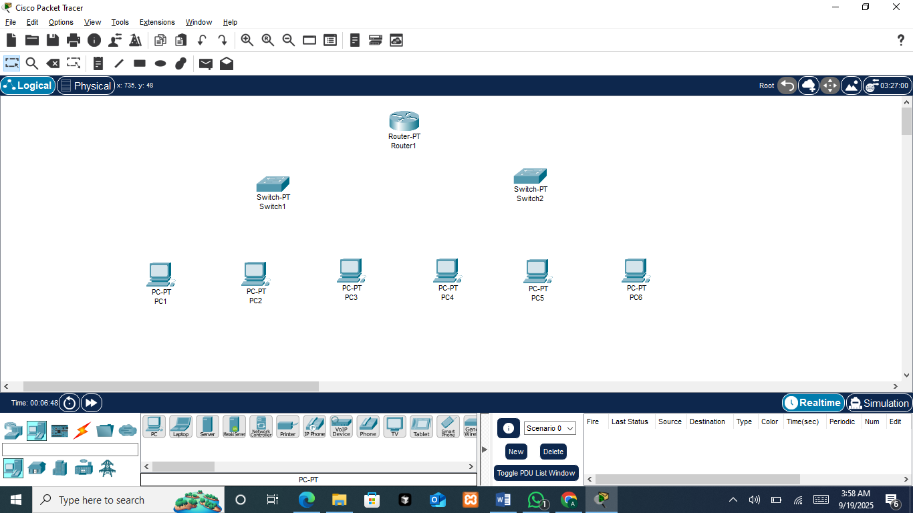
In this subnetting networking simulation schema, which consists of one router and two switches, PC1, PC2, and PC4 are configured to use a gateway, while PC3, PC5, and PC6 are not using a gateway.
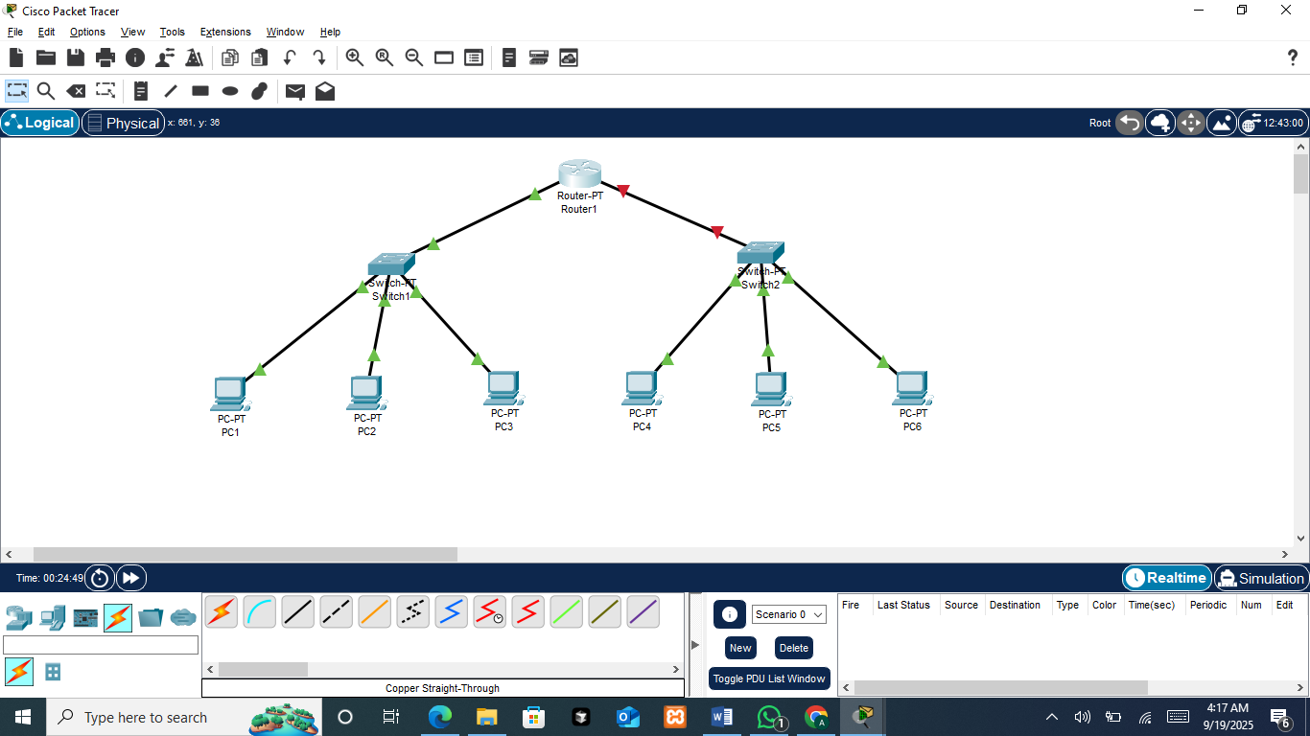
Next, the devices are connected using copper straight-through cables because they link different types of devices, such as PC to Switch and Switch to Router. Each PC is connected to its respective switch through the FastEthernet0 port, while each switch connects to the router through a FastEthernet or GigabitEthernet interface. Copper straight-through is the correct choice here, since it is standard for connecting end devices with intermediary devices, ensuring proper communication in the subnetting simulation.

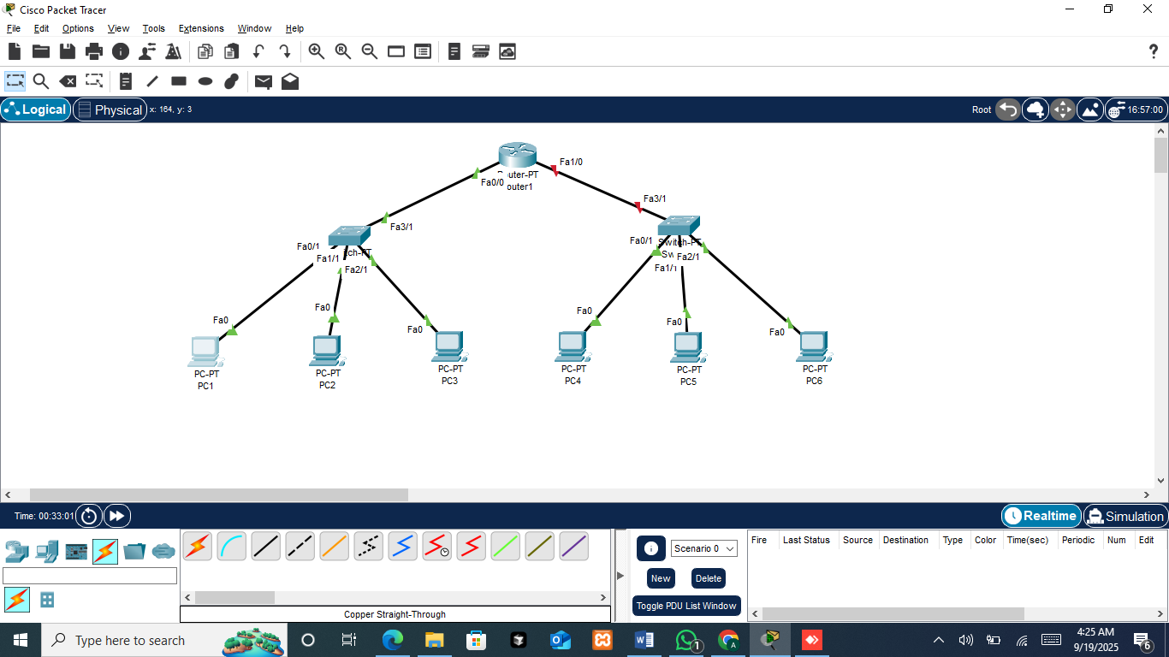
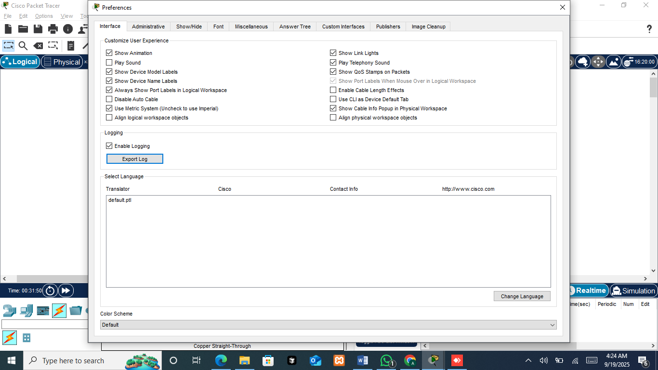
To display the port labels in Cisco Packet Tracer, go to the ‘Options’ menu, select ‘Preferences,’ and check the option ‘Always Show Port Labels in Logical Workspace’.
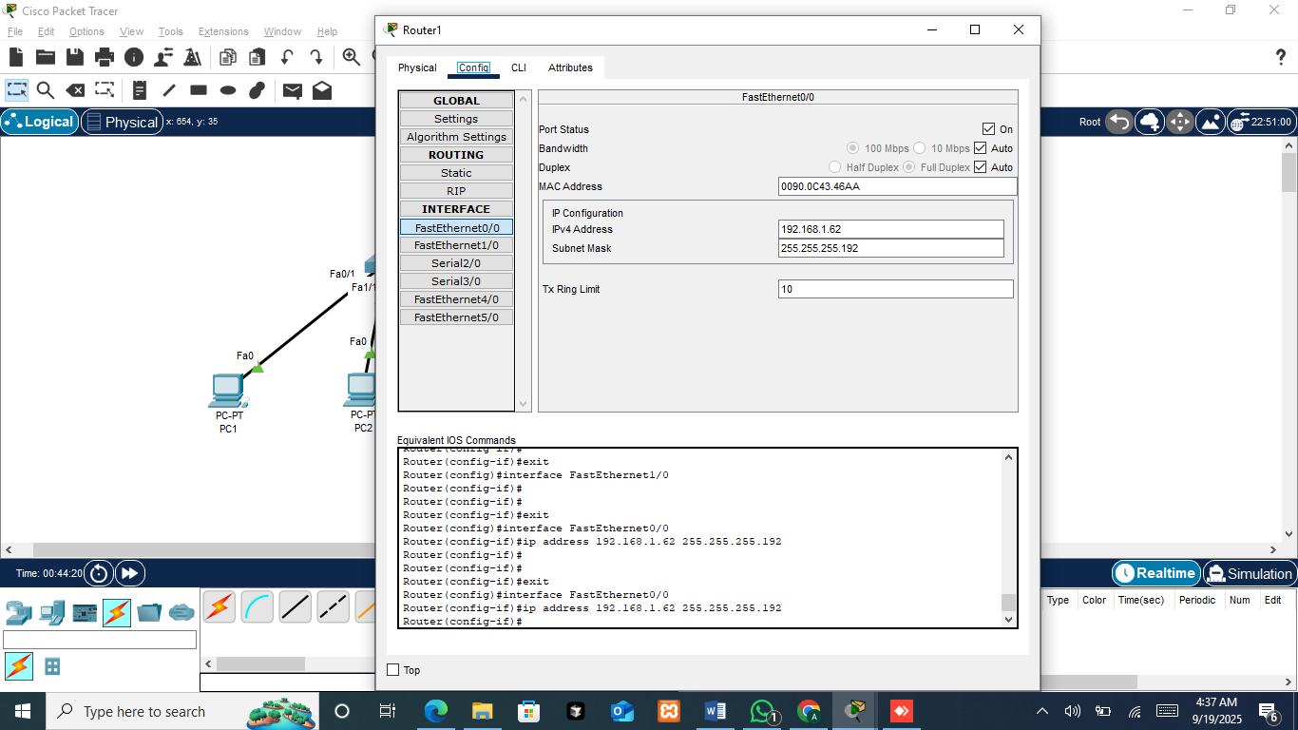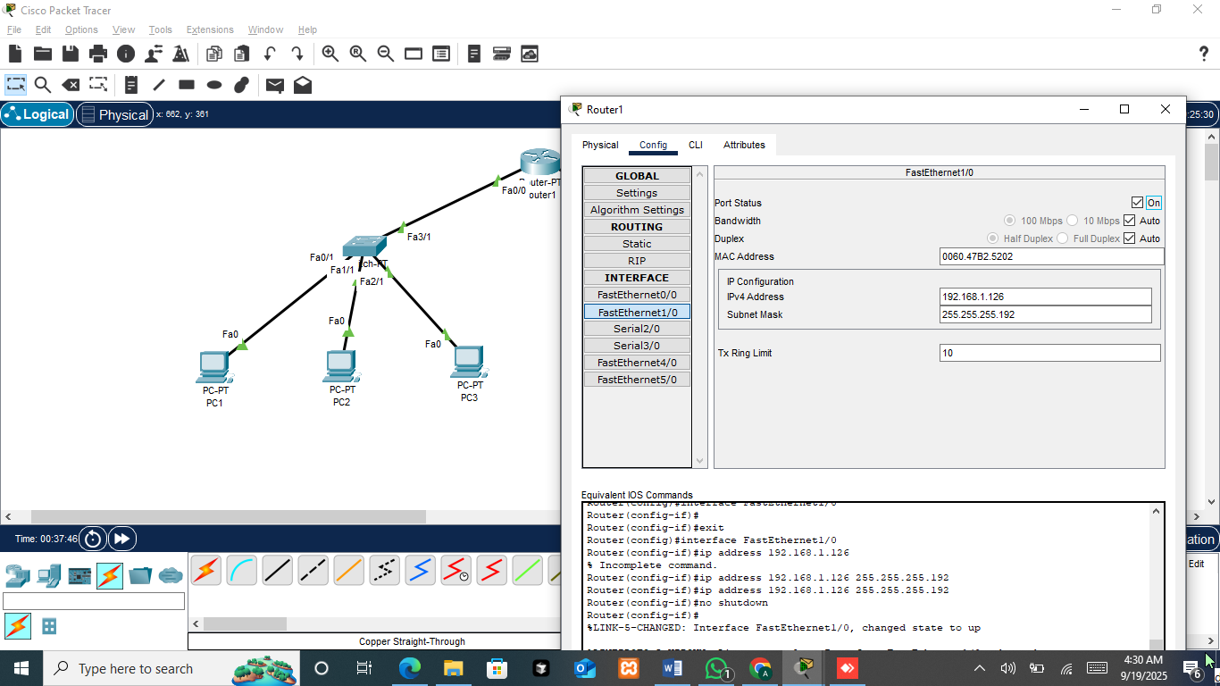
In this step, the router interfaces are configured with IP addresses and subnet masks to connect each subnet. FastEthernet0/0 is assigned the IP address 192.168.1.62 with subnet mask 255.255.255.192 for Lab 1, while FastEthernet1/0 is assigned the IP address 192.168.1.126 with the same subnet mask for Lab 2. Both interfaces are turned on to enable communication between the two subnets.
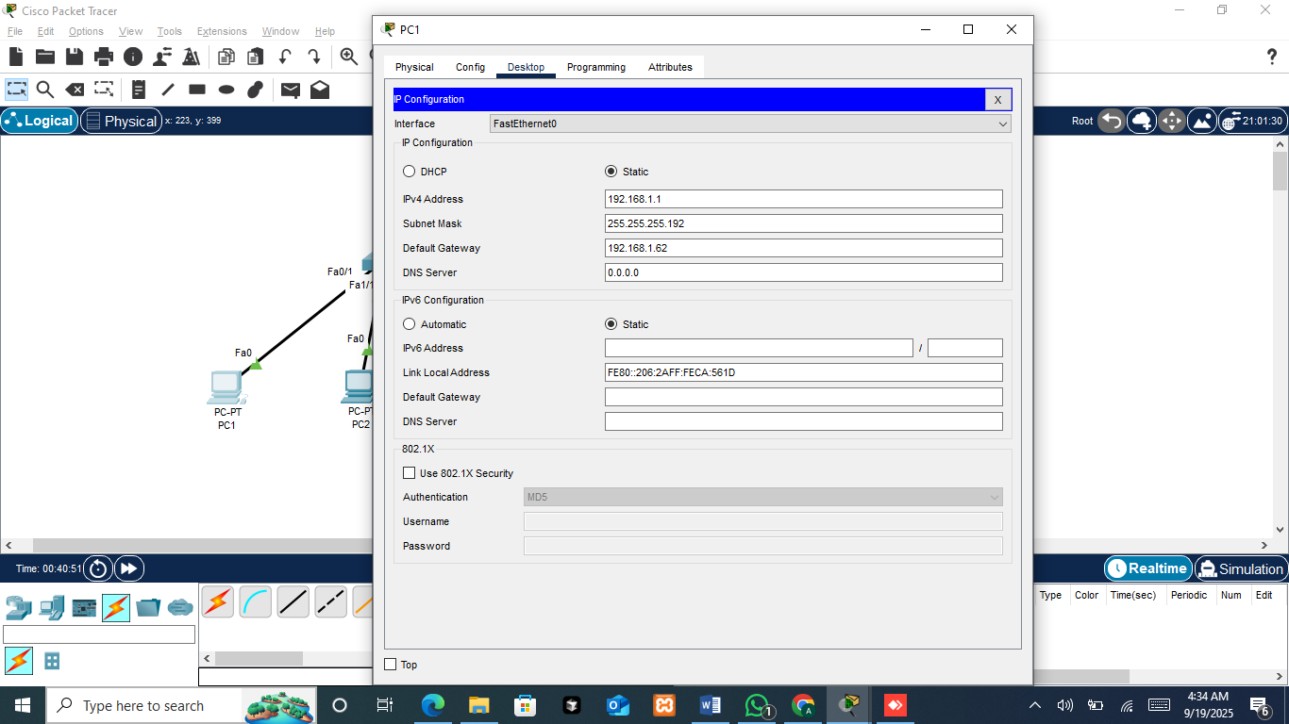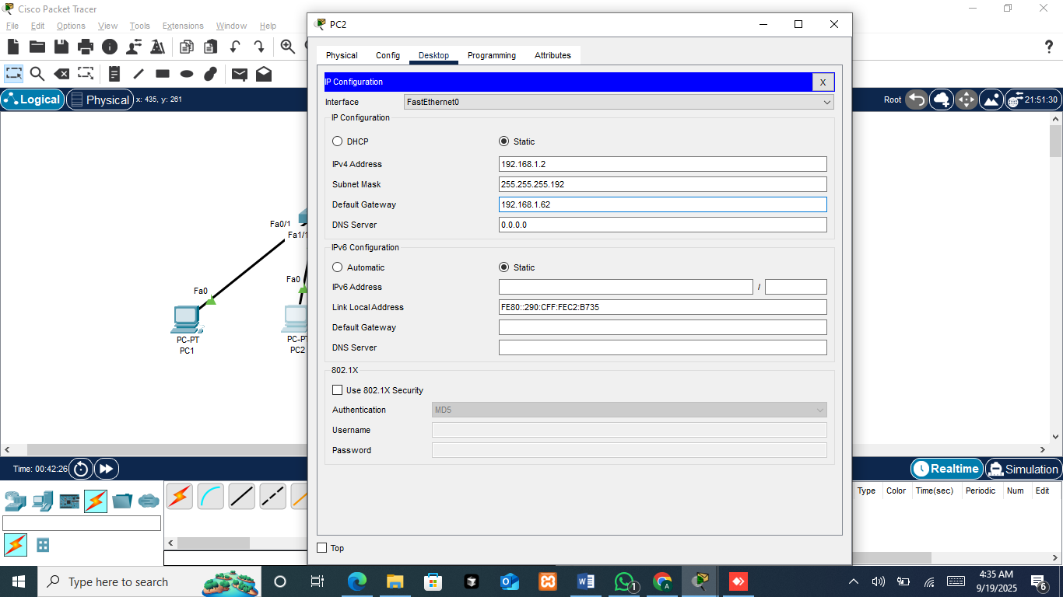

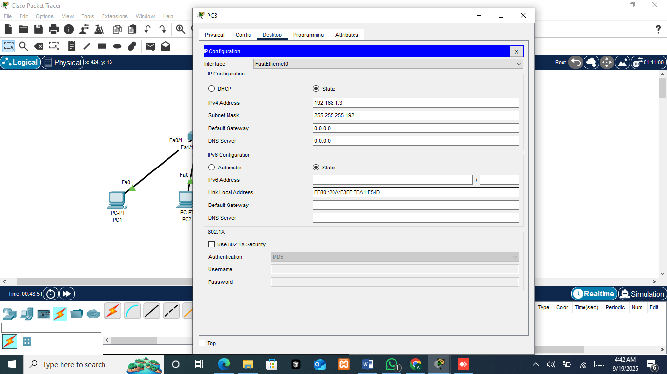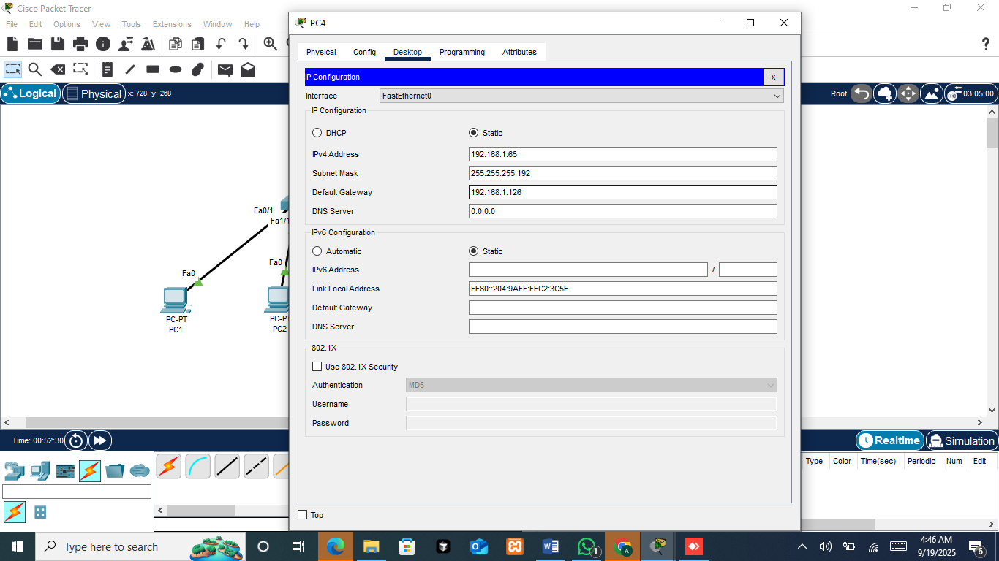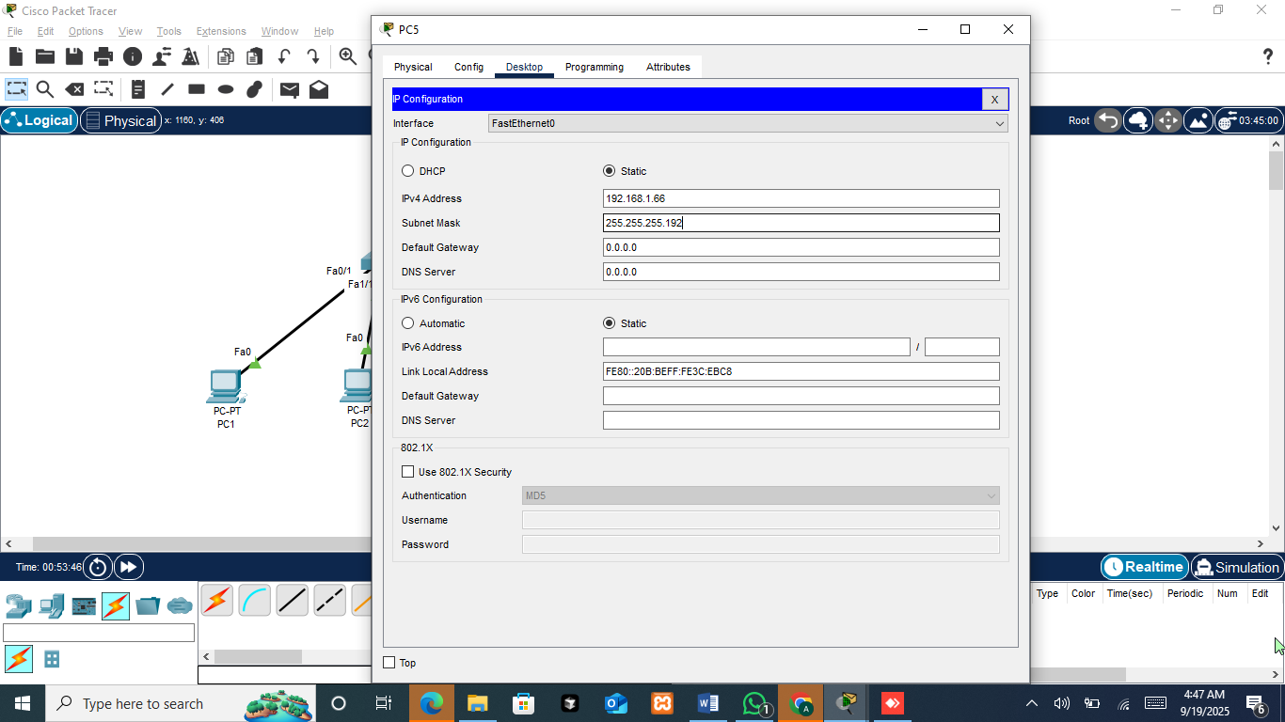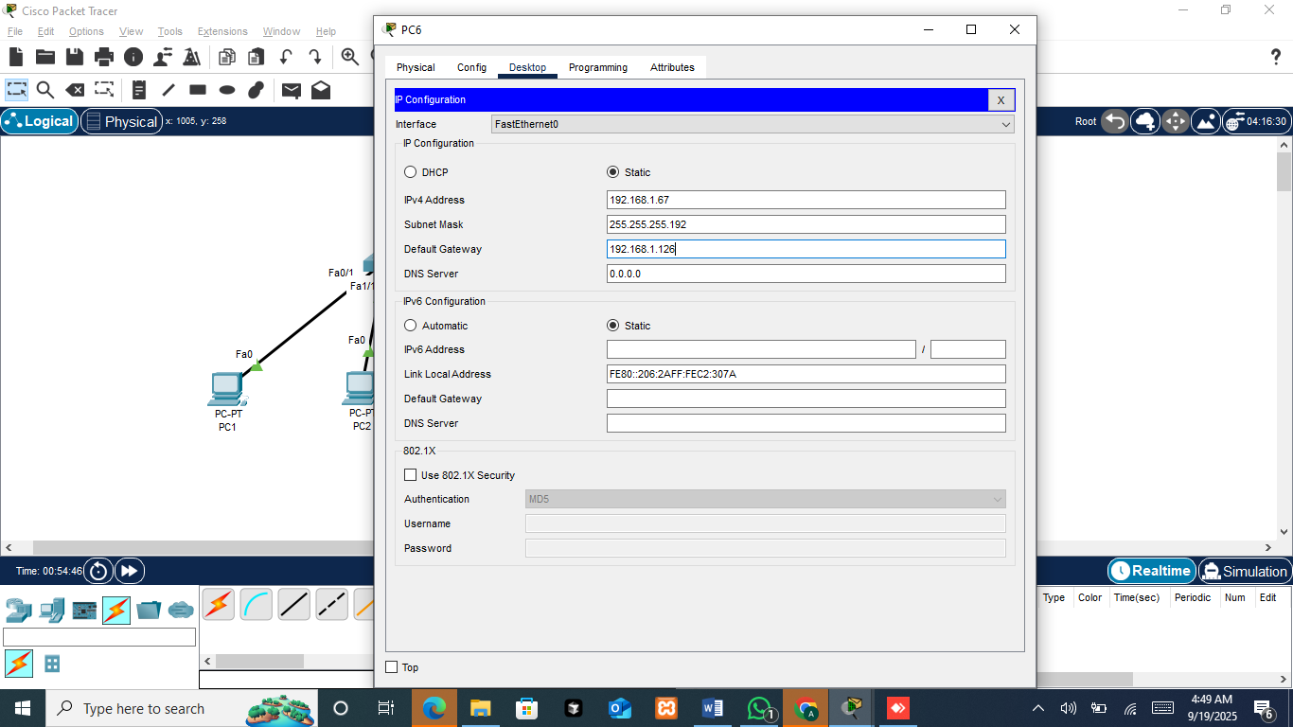
Each PC is configured with a static IP address, subnet mask, and in some cases a default gateway. For Lab 1, PC1 and PC2 use IP addresses 192.168.1.1 and 192.168.1.2 with gateway 192.168.1.62, while PC3 only uses an IP without a gateway. For Lab 2, PC4 and PC6 use IP addresses 192.168.1.65 and 192.168.1.67 with gateway 192.168.1.126, while PC5 is set without a gateway. This configuration ensures that some PCs can communicate across networks via the router, while others are limited to local subnet communication.
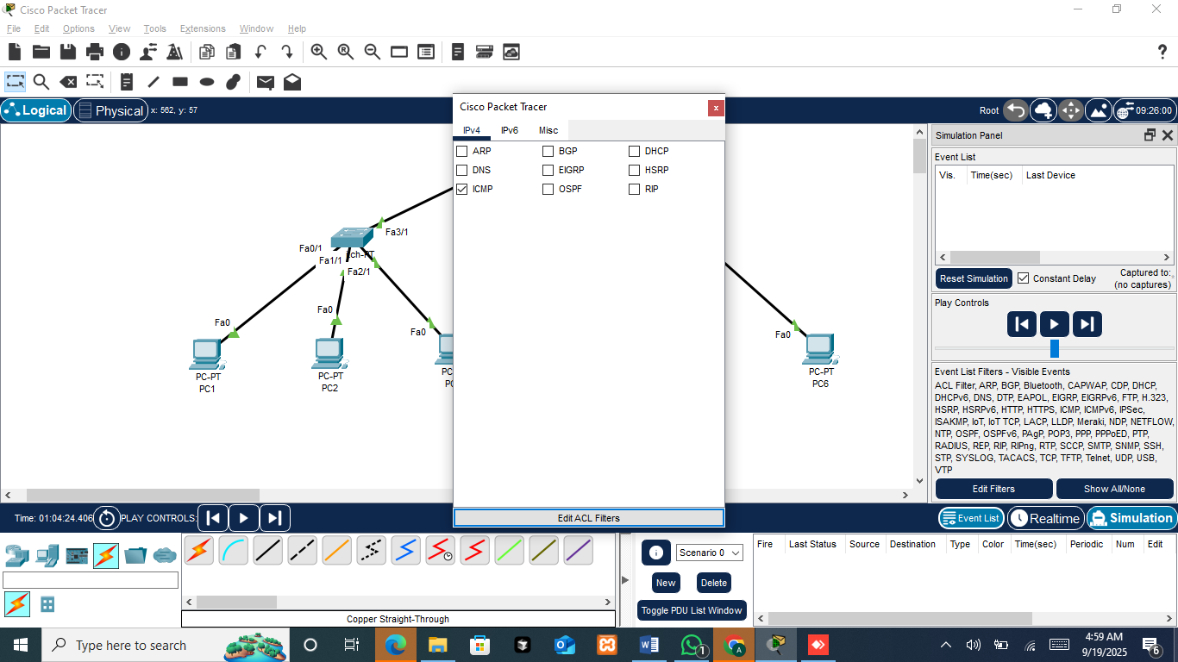
This screenshot shows the Packet Tracer Simulation Panel where protocols are filtered to observe network communication. In this case, the ICMP protocol is selected, which is used for ping tests. By enabling ICMP in the event list filters, the simulation will display only ICMP packets, making it easier to track connectivity tests between devices. This step is usually applied to confirm whether PCs can communicate within or across subnets.
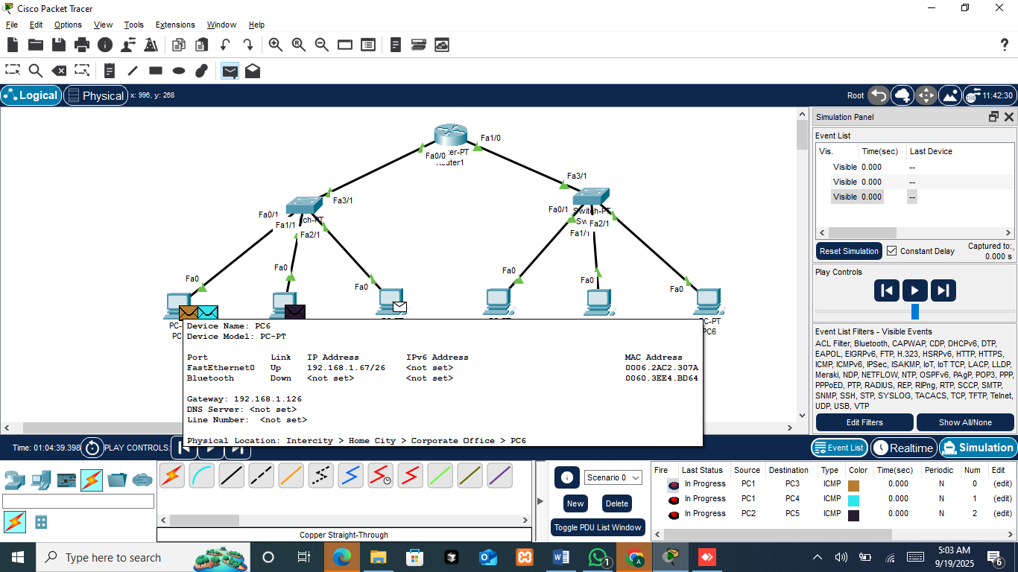
After configuring the IP addresses, the mode is switched to Simulation and the event list filter is set to IPv4 ICMP (Internet Control Message Protocol) to monitor ping packets. A simple PDU (Protocol Data Unit) is then sent between different PCs to test connectivity: from PC1 to PC3, from PC1 to PC4, from PC2 to PC5, and from PC3 to PC6. The simulation shows the path of each ICMP packet, allowing observation of whether communication is successful within the same subnet or across subnets through the router.
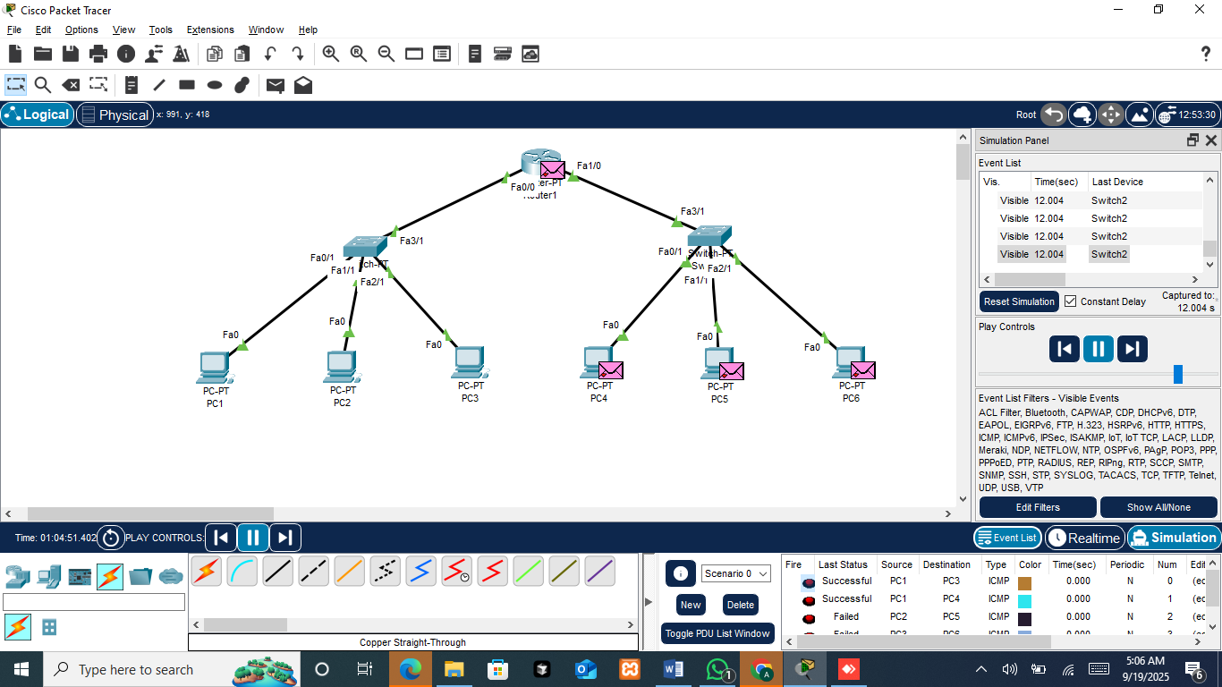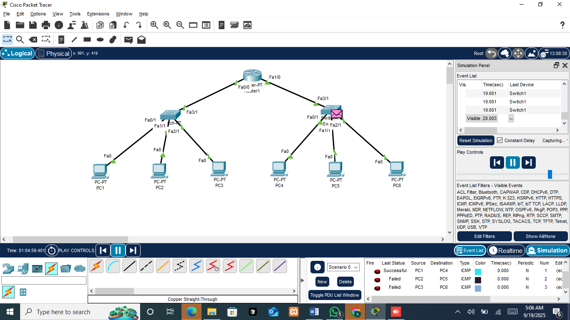
The simulation shows four ICMP (ping) tests between PCs. The packets sent from PC1 to PC3 and PC1 to PC4 were successful, while those from PC2 to PC5 and PC3 to PC6 failed. This difference occurs because only some PCs were configured with a default gateway.
- PC1 and PC2 (Lab 1 subnet)
PC1 has a gateway (192.168.1.62), so it can communicate across subnets, while PC2 does not have a gateway, limiting it to local subnet communication.
- PC3 (Lab 1 subnet)
No gateway was set, so it can only communicate within its local subnet.
- PC4 and PC6 (Lab 2 subnet)
Both are configured with a gateway (192.168.1.126), enabling communication across subnets.
- PC5 (Lab 2 subnet)
No gateway was set, restricting it to local communication only.
Reason for the Result
- Successful (PC1-PC3, PC1-PC4): PC1 has a gateway, so packets can reach both local and remote subnet devices.
- Failed (PC2-PC5, PC3-PC6): Since PC2 and PC3 do not have a gateway, they cannot forward packets outside their subnet, causing communication across subnets to fail.
So we can conclude, whether a PC can communicate across subnets depends on whether a gateway (router interface) is configured.
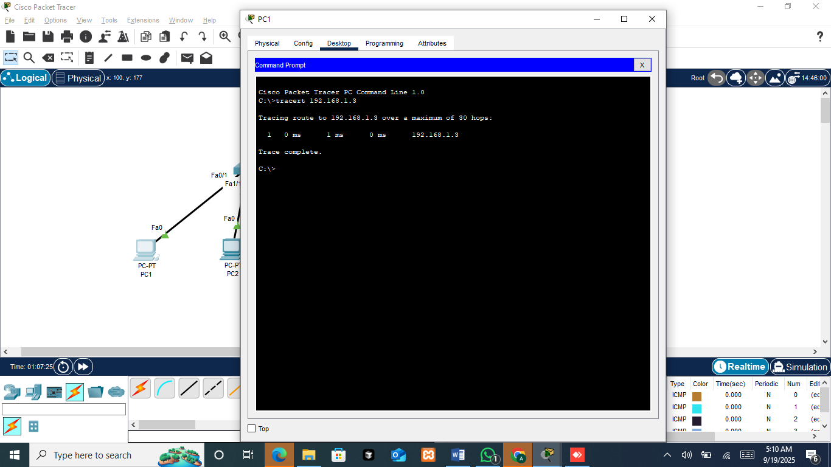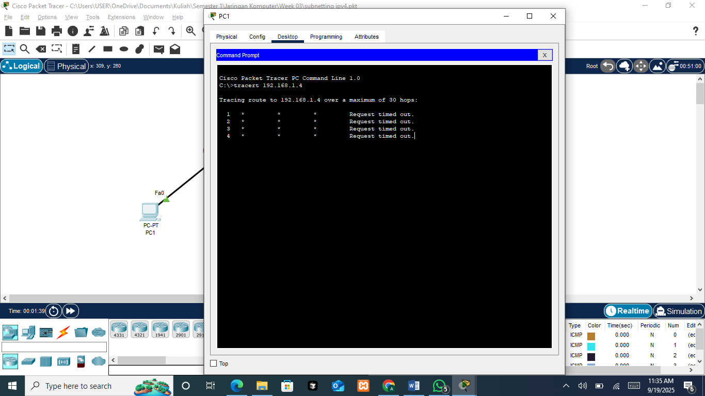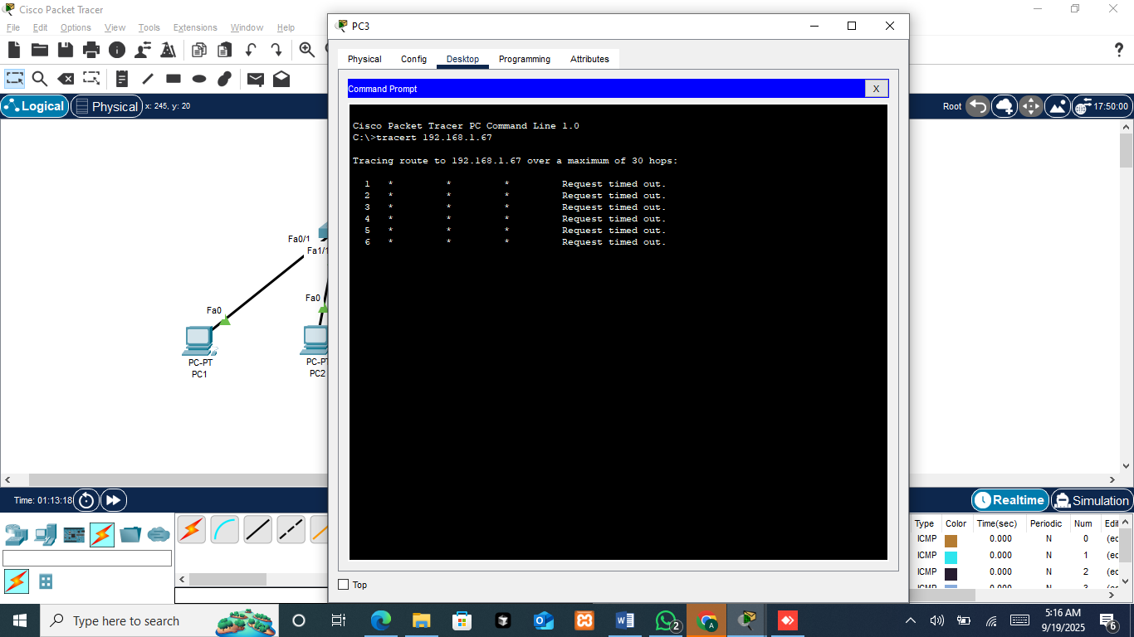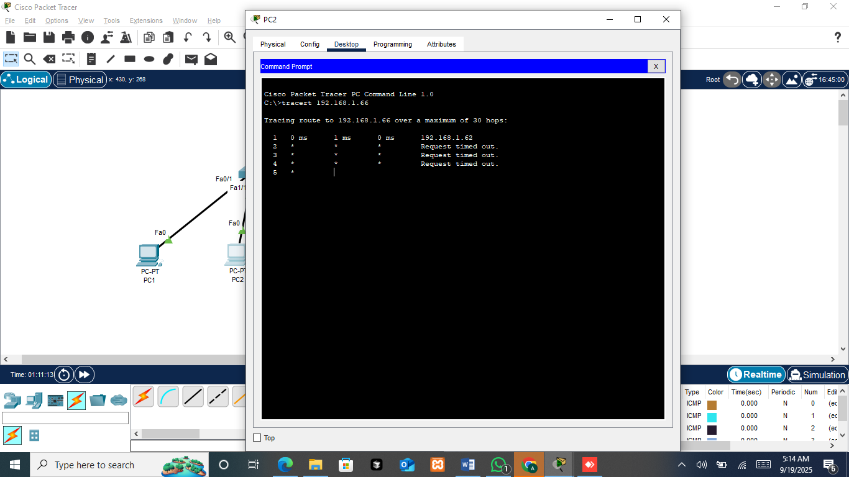
This screenshot shows the result of using the tracert command on several PCs to test connectivity.
- PC1 to PC3 (192.168.1.3): The trace is successful because both are in the same subnet, and communication happens directly without needing a gateway.
- PC1 to PC4 (192.168.1.4): The trace fails (request timed out) because PC4 is in another subnet and PC1 cannot reach it if routing or gateway configuration is incomplete.
- PC2 to PC5 (192.168.1.66): The trace starts but then fails after reaching 192.168.1.62 (the router interface). This shows PC2 reached the gateway but cannot continue further, since PC2 was not configured with a proper gateway.
- PC3 to PC6 (192.168.1.67): The trace fails completely because PC3 has no gateway set, so it cannot forward packets outside its subnet.
Successful traces happen only within the same subnet or when the PC has a valid gateway to forward packets across subnets. Failures occur when a gateway is missing, incorrectly set, or when the router cannot complete the route to the destination. This demonstrates the importance of proper gateway configuration for inter-subnet communication.
Conclusion
From this practicum, it can be concluded that subnetting is essential for dividing a network into smaller, more manageable subnets. By assigning proper IP addresses, subnet masks, and gateways, devices within the same subnet can communicate directly, while communication between different subnets requires the use of a router. The simulation in Packet Tracer also demonstrated how the configuration of each device influences connectivity, where PCs without a default gateway were limited to local communication only.
Furthermore, the use of simulation and real-time modes in Packet Tracer provided valuable insights into how data packets travel through a network. By observing ICMP packets in simulation mode, it became clear why some connections succeeded while others failed, reinforcing the importance of correct gateway configuration. Overall, this practicum enhanced understanding of subnetting concepts, device configuration, and the role of routers in enabling inter-subnet communication.

